|  |
| --- |
| prototipo-MDA |
| 13/12/16 21:53 |
| **Author:** John Doe  **File name:** prototipo-MDA.vp  **Version** 1.0 |

|  |
| --- |
| Site Map |
|  |

|  |
| --- |
|  |

01. Site Map / prototipo-MDA

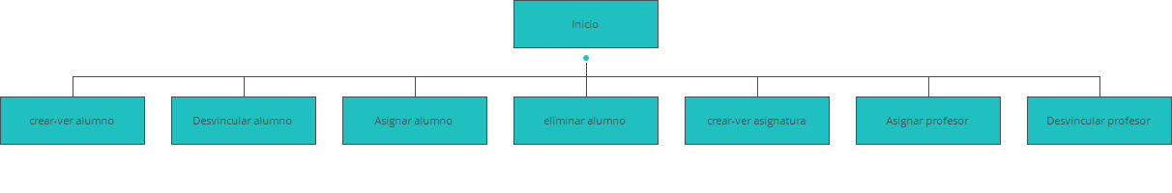

|  |
| --- |
| Screens |
|  |

|  |
| --- |
|  |

02. Screens / prototipo-MDA

Asignar alumno

|  |
| --- |
|  |

Interactions

|  |  |
| --- | --- |
| 1 | **on Mouse Over:** changes style of 'Label_2': Text 🡪 |
| 2 | **on Mouse Over:** changes style of 'Label_3': Text 🡪 |
| 3 | **on Mouse Over:** changes style of 'Label_4': Text 🡪 |

02. Screens / prototipo-MDA

Asignar profesor

|  |
| --- |
|  |

Interactions

|  |  |
| --- | --- |
| 13 | **on Mouse Over:** changes style of 'Label_2': Text 🡪 |
| 14 | **on Mouse Over:** changes style of 'Label_3': Text 🡪 |
| 15 | **on Mouse Over:** changes style of 'Label_4': Text 🡪 |

02. Screens / prototipo-MDA

crear-ver asignatura

|  |
| --- |
|  |

Interactions

|  |  |
| --- | --- |
| 25 | **on Mouse Over:** changes style of 'Label_2': Text 🡪 |
| 26 | **on Mouse Over:** changes style of 'Label_3': Text 🡪 |
| 27 | **on Mouse Over:** changes style of 'Label_4': Text 🡪 |

02. Screens / prototipo-MDA

crear-ver alumno

|  |
| --- |
|  |

Interactions

|  |  |
| --- | --- |
| 37 | **on Mouse Over:** changes style of 'Label_2': Text 🡪 |
| 38 | **on Mouse Over:** changes style of 'Label_3': Text 🡪 |
| 39 | **on Mouse Over:** changes style of 'Label_4': Text 🡪 |

02. Screens / prototipo-MDA

Desvincular alumno

|  |
| --- |
|  |

Interactions

|  |  |
| --- | --- |
| 49 | **on Mouse Over:** changes style of 'Label_2': Text 🡪 |
| 50 | **on Mouse Over:** changes style of 'Label_3': Text 🡪 |
| 51 | **on Mouse Over:** changes style of 'Label_4': Text 🡪 |

02. Screens / prototipo-MDA

Desvincular profesor

|  |
| --- |
|  |

Interactions

|  |  |
| --- | --- |
| 61 | **on Mouse Over:** changes style of 'Label_2': Text 🡪 |
| 62 | **on Mouse Over:** changes style of 'Label_3': Text 🡪 |
| 63 | **on Mouse Over:** changes style of 'Label_4': Text 🡪 |

02. Screens / prototipo-MDA

eliminar alumno

|  |
| --- |
|  |

Interactions

|  |  |
| --- | --- |
| 73 | **on Mouse Over:** changes style of 'Label_2': Text 🡪 |
| 74 | **on Mouse Over:** changes style of 'Label_3': Text 🡪 |
| 75 | **on Mouse Over:** changes style of 'Label_4': Text 🡪 |

02. Screens / prototipo-MDA

Inicio

|  |
| --- |
|  |

Interactions

|  |  |
| --- | --- |
| 85 | **on Mouse Over:** changes style of 'Label_2': Text 🡪 |
| 86 | **on Mouse Over:** changes style of 'Label_3': Text 🡪 |
| 87 | **on Mouse Over:** changes style of 'Label_4': Text 🡪 |

|  |
| --- |
| Templates |
|  |

|  |
| --- |
|  |

03. Templates / prototipo-MDA

960 grid - 12 columns

|  |
| --- |
|  |

03. Templates / prototipo-MDA

960 grid - 16 columns

|  |
| --- |
|  |

03. Templates / prototipo-MDA

Template 1

|  |
| --- |
|  |

|  |
| --- |
| Scenarios |
|  |

|  |
| --- |
|  |

04. Scenarios / prototipo-MDA

default

|  |
| --- |
|  |